***BEEE LAB***

***EXPERIMENT-5***

**Automatic Night lamp**

UID: 19BCCS6151

NAME: SANCHIT

BRANCH: CSE AIML2

**Night lamp**

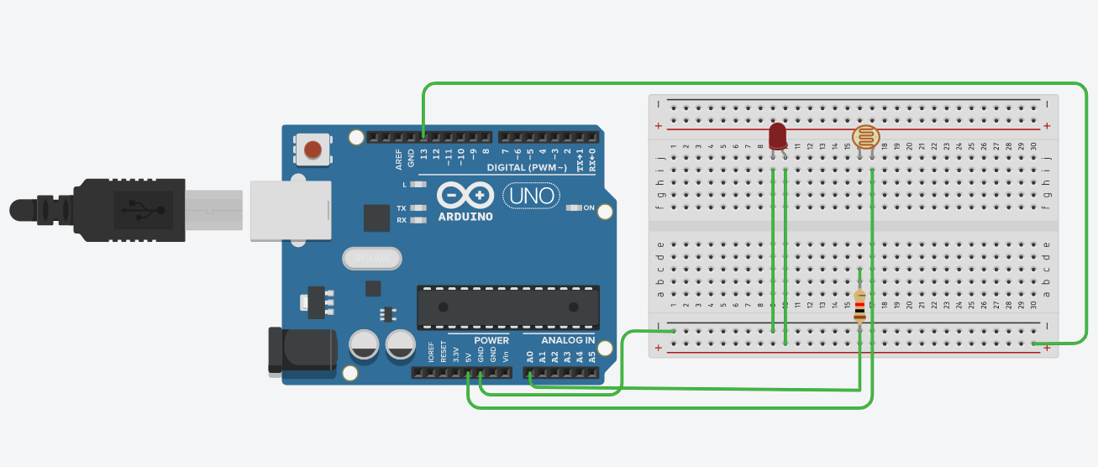

***Theory***

***CONCEPT Used :***

1) A circuit consists of 2 digital pins are used where a pin i.e., 13 making connection of LED with Arduino and further making the connection to the ground.

2)Now one terminal of LDR is connected to ground and another is connected to resistor of 10K ohm and the same terminal is also connected to the A0.

3)Now the 10K ohm resistor is connected to LDR and another terminal is connected to 5V supply.

4)When light rays falls on the LDR increases resistance of LDR decreases and hence LED glows.

***Learning and Observations : -***

1)I have learnt to use Arduino Board and how the code will work whenever the light falls on the LDR resistance decreases and LED does not glow.

2)How a circuit is placed on breadboard so that it can work properly.

3)Arduino board has Digital pins and Analog pins.

Digital pin provides Input as well as Output, but Analog pin provides only input.

4)The Arduino board has ~ sign in Digital pin side which is also known as Pulse Width Modulation(PWM)**.**

These pins help’s in getting Analog signals with digital means.

***Problems and Troubleshooting:***

* Making a functional was a bit time taking as it becomes a bit confusing on arranging the wires.
* Minors errors showed up in the code during the test run, which was troubleshooted by the correcting the above.

***Precautions :-***

1. Correction should be correct.

2. Using Multimeter to check whether all the devices are in working

condition or not.

3. Correct sets of instructions are provided or not to perform the specific

function.

***Learning Outcomes: –***

1. Setting up correct connections to the Arduino.

2. Connecting LDR, LED and Arduino.

3. Using LDR and LED to design circuits.

4. Working and coding of Arduino.